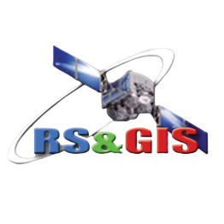
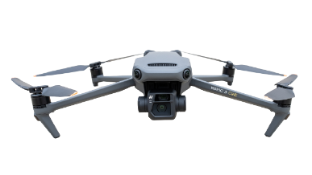
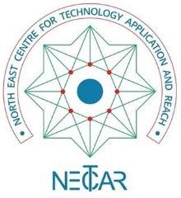
North East Centre for Technology Application and Reach (NECTAR)
An Autonomous body under the Department of Science & Technology
Govt. of India

Application Format for Geospatial Training Modules in NECTAR
(To be completed by the APPLICANT – Please fill in with CAPITAL letters only)
- Select one or more Modules to undertake(Please check the schedule, Couse Fee and syllabus before application and availability):
Module 1 (Remote Pilot Certification & Licensing (RPCL))
Module 2 (Drone Awareness Training Program (DAT))
Module 3 (Drone Data Acquisition & Processing (DDAP))
Module 4 (Basics of GIS &Remote Sensing (GISRS))
Paste Recent passport size Photographs signed across.
- Applicant’s name as per the matriculation certificate mark sheet
…………………………………………………………………………
- Address for communication: ………………………………………..
…………………………………………………………………………
- Permanent address: …………………………………………………
…………………………………………………………………………
- Email ID: ……………………………………………………………..
- Mobile: …………………….. Alternate number: ………………….
- Gender: Male/Female
- Social Status: SEBC/OBC/SC/ST/General
- Weather the candidate is belongs to North East Region state Domicile: Yes/No
(Strike out which is not applicable)
- Academic detail:
Sl. No. | Name of School/Institute attended | Exam passed | Year of passing | Subjects | Class/Division | % of marks

- Registration Fee Paid : Yes -Transaction Id: (attach acknowledgement receipt.)
- Declaration:

I ………………………………………… undertake that the information furnished above is correct and best of my knowledge and I am willing to undertake the above-mentioned training program(s)/modules as per the terms of NECTAR.

- Please attach copies of photo identity proof, proof of social status, educational certificates/documents and CV with this application form.

Signature
Place:
Date:

Forward the completed application along with supporting documents via email (Signed Scanned Copy) @ nectartraining@nectar.org.in or by Post to NECTAR Office at Survey of India Campus, Bonnie Brae Estate, Barik Point, Shillong, and Meghalaya-793001.

